Assignment # 2

Name: Iqra Khalid

Roll no: BSIT-M1-19-60

Submitted to: Sir Rana Abu bakr

Univerity of sahiwal



***Hackrone***

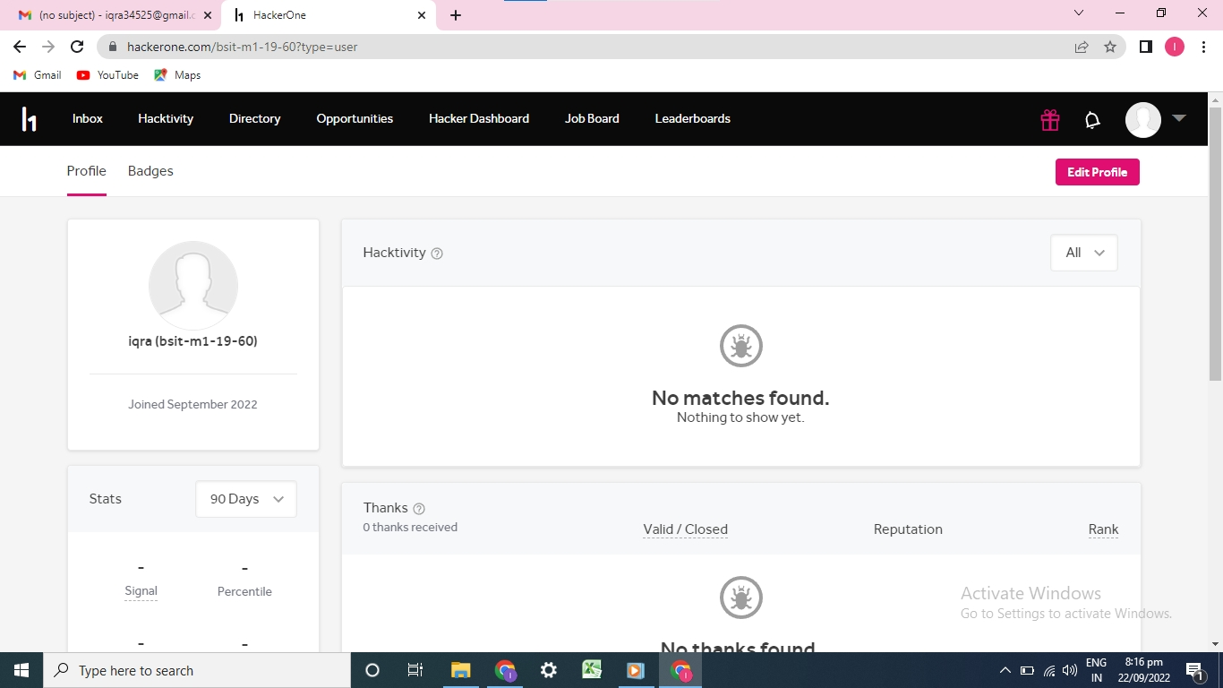

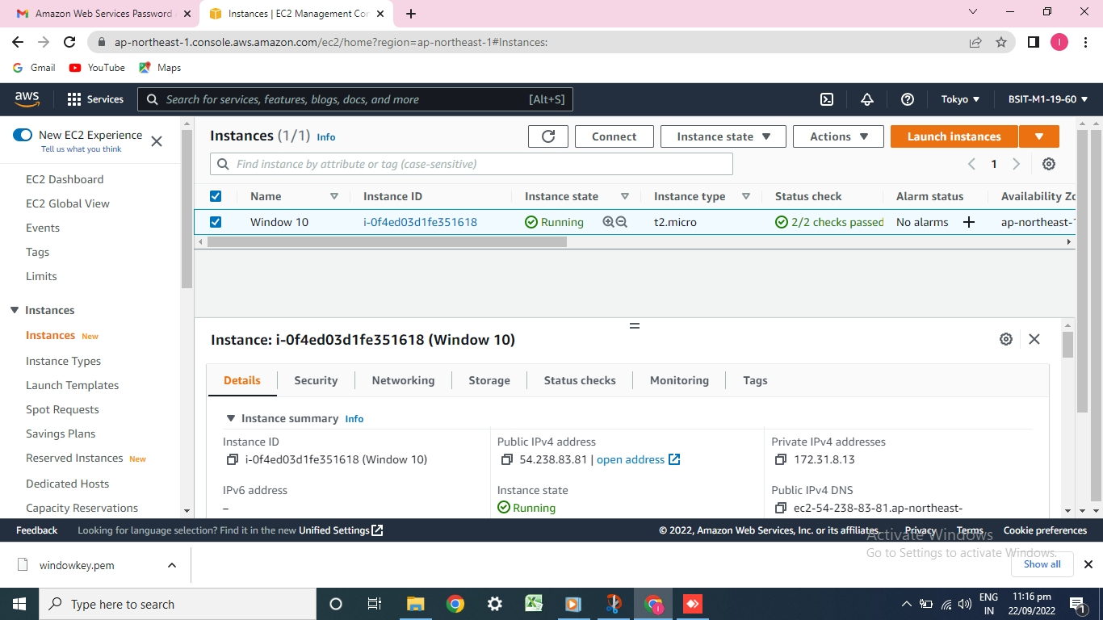***Windows 10 on AWS***

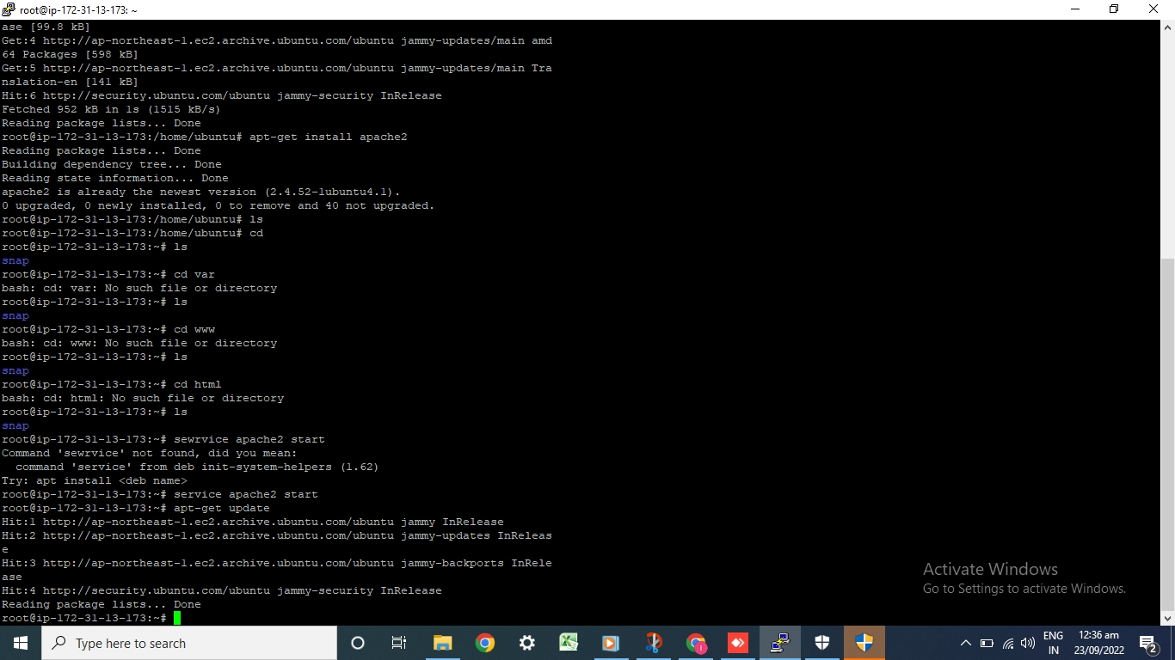**Commands for Ubanto**

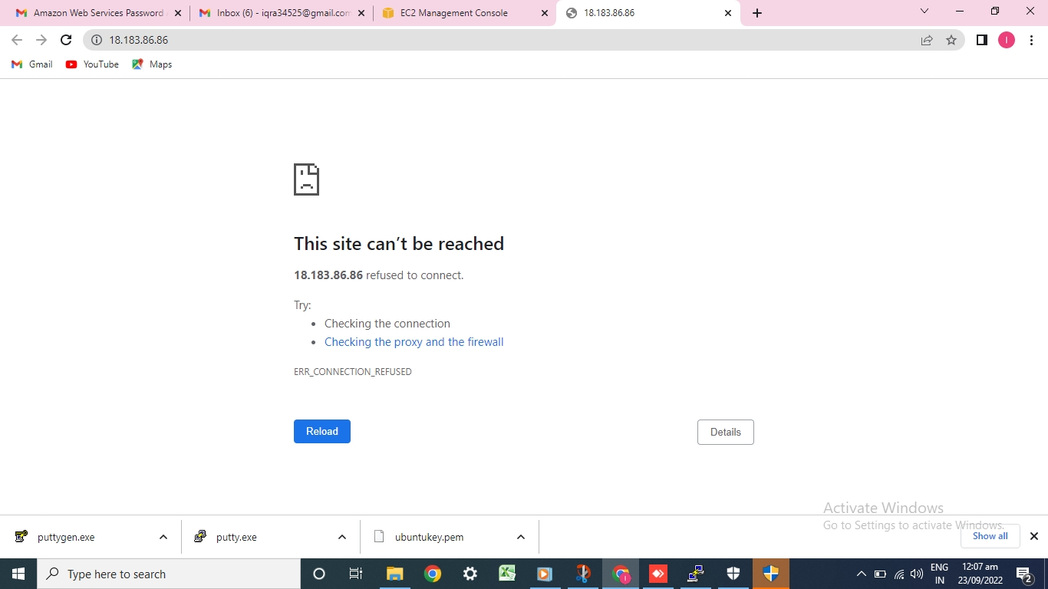

***GitHub Account***

